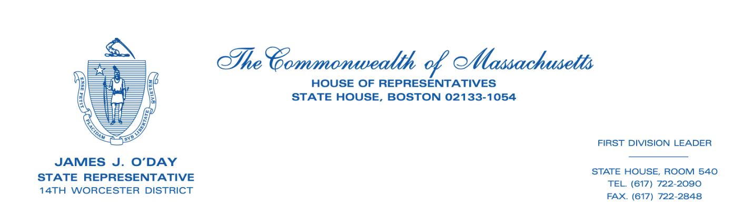
FOR IMMEDIATE RELEASE

CONTACT
Anna Duffy, Office of State Representative James O’Day
anna.duffy@mahouse.gov
REPRESENTATIVE O’DAY AND COLLEAGUES PASS THE FISCAL YEAR 2023 MASSACHUSETTS STATE BUDGET
Massachusetts House and Senate agree to $52.7 billion budget

(Boston, MA- 07/19/2022) Yesterday, Representative James O’Day (14th Worcester District) and his colleagues in the Massachusetts House of Representatives and Senate unanimously passed the state’s fiscal year 2023 (FY23) budget. Representative O’Day successfully secured vital funding for his constituents in the city of Worcester and town of West Boylston.

The FY23 budget makes strategic investments and takes advantage of an unexpected budget surplus from the previous fiscal year. The spending plan dedicates $6 billion in Chapter 70 funding, $1.23 billion for Unrestricted General Government Aid, $226 million to the MBTA for a safety and workforce reserve, $110 for the free school meals initiative, and $2 million supporting reproductive health care access. Massachusetts is also readily prepared for a slower economic pace next year; the budget puts $1.5 billion into the state’s stabilization fund.

“Massachusetts’ FY23 budget recognizes and supports the needs of our most vulnerable communities. While many economists are predicting a slower economy next year, Massachusetts is ready to weather the storm” said Representative O’Day in response to the budget’s passage. “This budget is not possible without the steadfast leadership of Speaker Ron Mariano, House Ways and Means Chair Aaron Michlewitz, and their staffers. I am also grateful to my colleagues of the Worcester delegation for their teamwork and support.”

Representative O’Day secured funding for important initiatives in Worcester and West Boylston:
- $50,000 for the John J. Binienda Center for Civic Education at Worcester State University
- $150,000 to renovate Mixter field in West Boylston
- $150,000 for the Worcester Tree Initiative, which continues the reforestation of areas in Worcester where trees had to be removed due to heavy Asian long-horned beetle infestation
- $200,000 for the North Main Street Sidewalk in the town of West Boylston
- $1.3 million for Court Appointed Special Advocate Program (CASA), including $330,000 for Worcester County CASA

As House Chair of the Ellen Story Commission on Postpartum Depression, Representative O’Day advocated for money for state-wide postpartum depression care and research:
- $360,000 earmark for the Department of Public Health (DPH) to conduct a postpartum depression pilot program at community health centers in the cities of Holyoke, Lynn, Worcester, Fall River, Salem, and Jamaica Plain

The budget now goes to the desk of Governor Charlie Baker. The Governor has ten days to act on the budget.
###

